1. 网络题
2. IBM Systems Network Architecture (SNA), role in the history, still used, not replaced with latest network .

**IBM系统网络架构**（英语：**S**ystems **N**etwork **A**rchitecture，缩写为**SNA**）由[IBM](https://zh.wikipedia.org/wiki/IBM" \o "IBM)公司在1974年该公司[大型主机](https://zh.wikipedia.org/wiki/%E5%A4%A7%E5%9E%8B%E4%B8%BB%E6%A9%9F" \o "大型主机)网络架构所订定的网络结构标准和通讯协定。后来[ISO](https://zh.wikipedia.org/wiki/ISO" \o "ISO)（国际标准组织）使用[IBM](https://zh.wikipedia.org/wiki/IBM" \o "IBM)的SNA架构作为它的[OSI模型](https://zh.wikipedia.org/wiki/OSI%E6%A8%A1%E5%9E%8B" \o "OSI模型)（开放式系统架构）的原始模型架构，OSI 所包含七层架构为：

* 第一层：**实体层**（Physical layer）允许多种不同类型的实体连接。
* 第二层：**资料连接层**（Data－link layer）确保实体层连结的资料之正确性，包含资料传输的错误侦测及更正功能。
* 第三层：**网络层**（Network layer）建立及管理节点到另一个节点的路径。
* 第四层：**传输层**（Transmission layer）确保资料在网络层与对话层之间的传输品质。
* 第五层：**对话层**（Session layer）主要在管理各使用者之间资料的交换形式。
* 第六层：**展现层**（Presentation layer）负责将传输的资讯以有意义的形式表达给网络使用者，并提供应用程序界面。
* 第七层：**应用层**（Application layer）是[OSI](https://zh.wikipedia.org/wiki/OSI%E6%A8%A1%E5%9E%8B" \o "OSI模型)最高层，其提供了使用者网络上的服务。

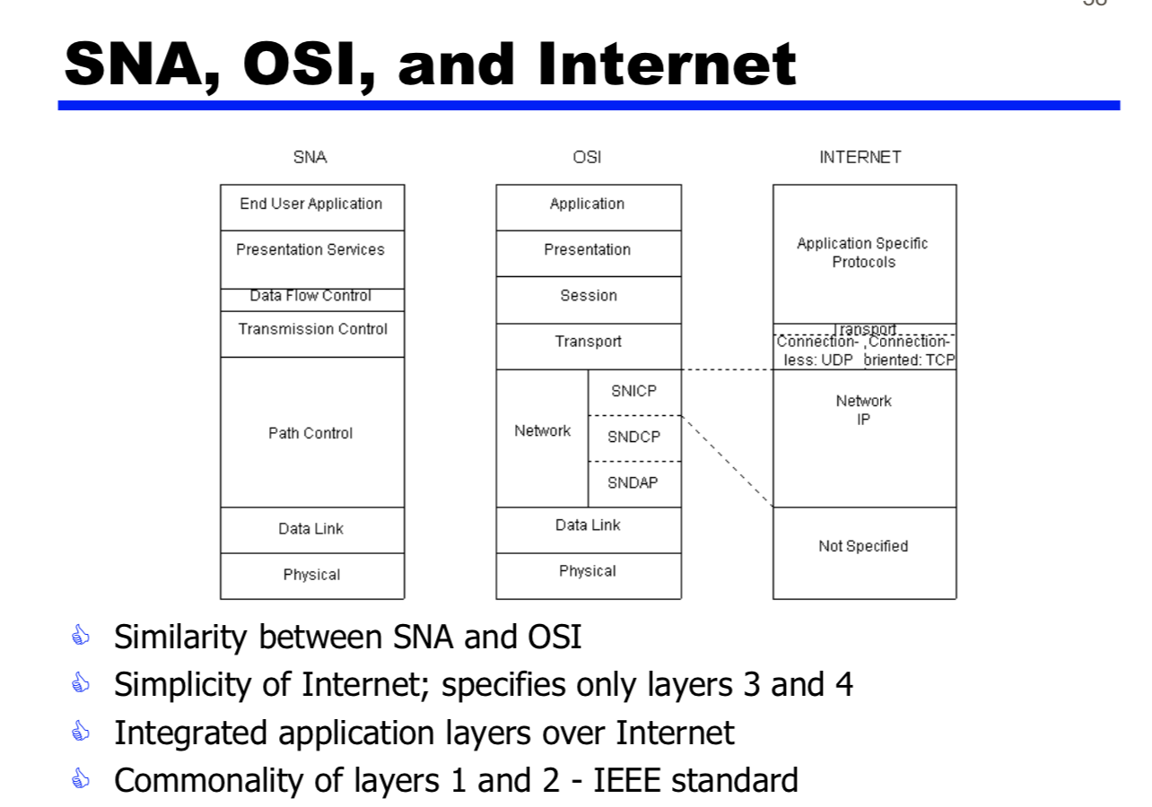

1. Why slotted ALOHA protocol was proposed after ALOHA protocol, more efficient

* Pure ALOHA Protocol
* 当传输点有数据需要传送的时候，它会立即向通讯频道传送。
* 接收点在收到数据后，会ACK传输点。
* 如果接收的数据有错误，接收点会向传输点发送NACK。
* 当网络上的两个传输点同时向频道传输数据的时候，会发生冲突，这种情况下，两个点各自等待一段随机长度的时间后，再次尝试传送。
* Frame may be damaged by noise or by another station transmitting at the same time (collision)
* Any overlap of frames causes collision

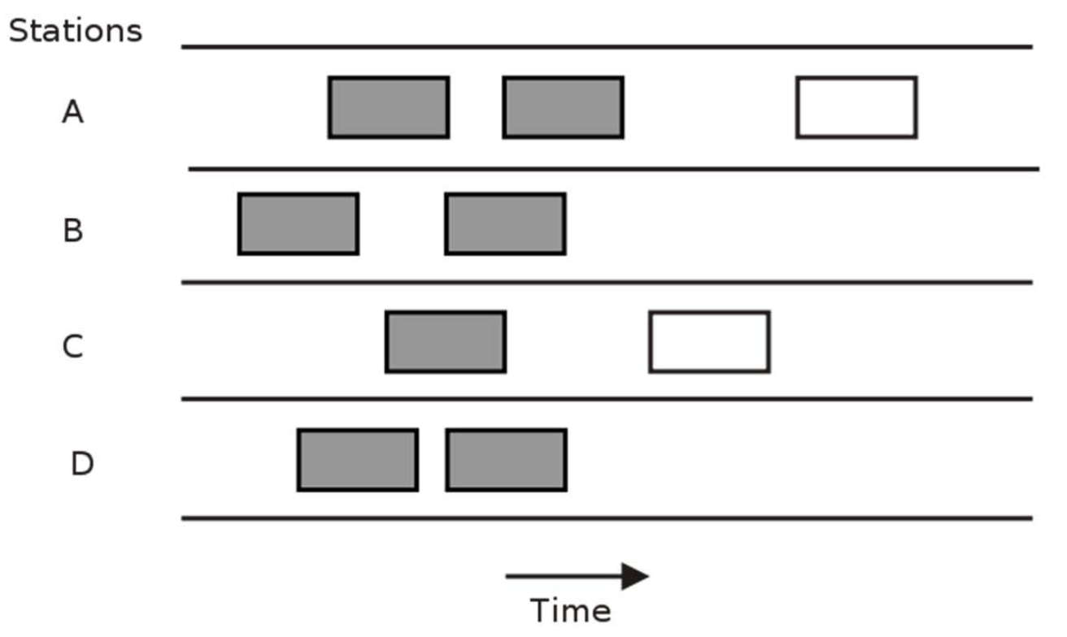

* 分段ALOHA(Slotted ALOHA)
* **把频道在时间上分段，每个传输点只能在一个分段的开始处进行传送。每次传送的数据必须少于或者等于一个频道的一个时间分段。这样大大的减少了传输频道的冲突。**
* Time in uniform slots equal to frame transmission time
* Need central clock (or other sync mechanism)
* Transmission begins at slot boundary
* Frames either miss or overlap totally
* Max utilization 37%

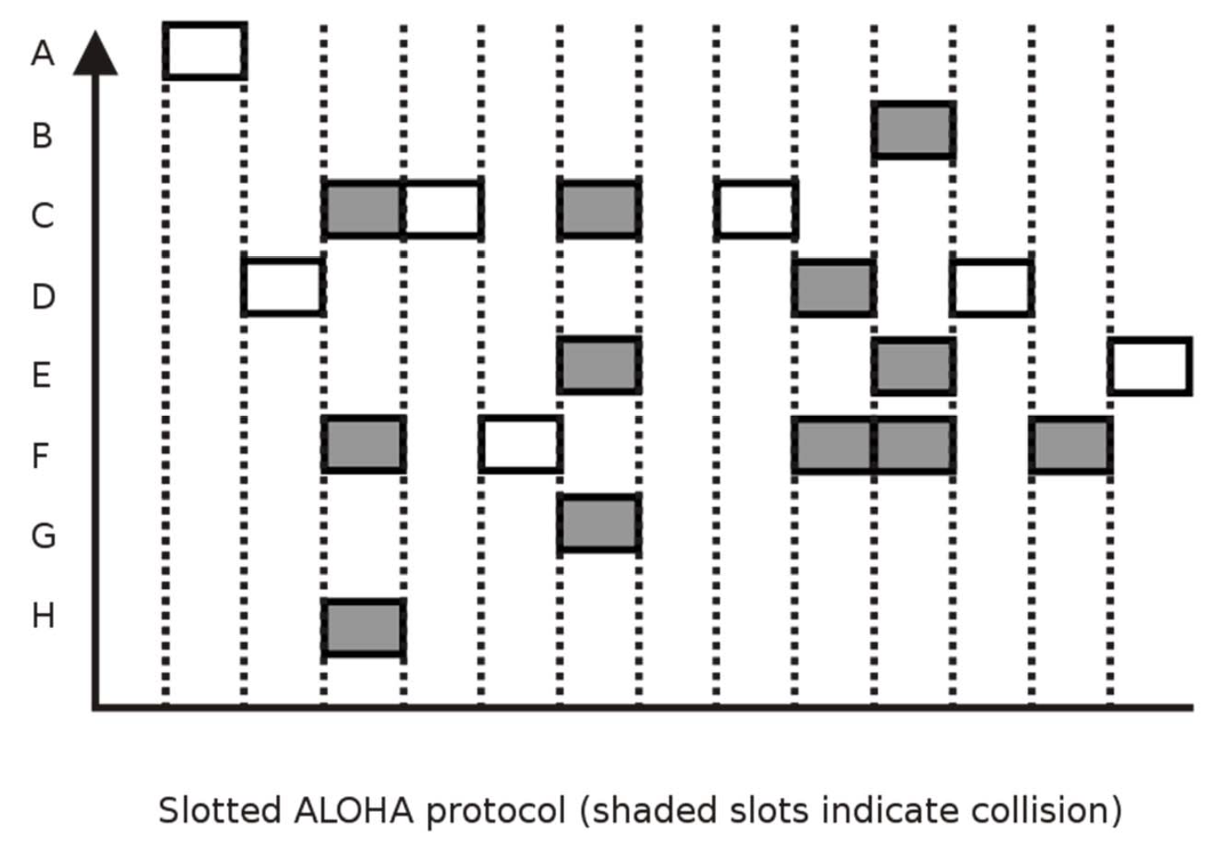

1. First Generation Lan: CSMA/CD

Carriers Sense Multiple Access with Collision Detection

Which is preferred in Heavy load of networks, CSMA/CD or Token Ring

CSMA/CD protocol has constant utilization irrespective of network traffic load, length limits on single segments and network packets.

**载波侦听多路访问**（Carrier Sense Multiple Access, CSMA）是一种[介质访问控制](https://zh.wikipedia.org/wiki/%E4%BB%8B%E8%B4%A8%E8%AE%BF%E9%97%AE%E6%8E%A7%E5%88%B6" \o "介质访问控制)(MAC)的协议。

**载波侦听**（Carrier Sense）指任何连接到介质的设备在欲发送帧前，必须对介质进行侦听，当确认其空闲时，才可以发送。

**多路访问**（Multiple Access）指多个设备可以同时访问介质，一个设备发送的帧也可以被多个设备接收。

此方案要求设备在发送帧的同时要对信道进行侦听，以确定是否发生碰撞，若在发送数据过程中检测到碰撞，则进行如下碰撞处理操作：

1. 发送特殊阻塞信息并立即停止发送数据：特殊阻塞信息是连续几个字节的全1信号，此举意在强化碰撞，以使得其它设备能尽快检测到碰撞发生。
2. 在固定时间（一开始是1 contention period times）内等待随机的时间，再次发送。
3. 若依旧碰撞，则采用[截断二进制指数避退算法](https://en.wikipedia.org/wiki/truncated_binary_exponential_backoff" \o "en:truncated binary exponential backoff)进行发送。即十次之内停止前一次“固定时间”的两倍时间内随机再发送，十次后则停止前一次“固定时间”内随机再发送。尝试16次之后仍然失败则放弃发送。

此方案应用于 [以太网](https://zh.wikipedia.org/wiki/%E4%BB%A5%E5%A4%AA%E7%BD%91)（DIX Ethernet V2）标准，[IEEE 802.3](https://zh.wikipedia.org/wiki/IEEE_802.3" \o "IEEE 802.3)标准。

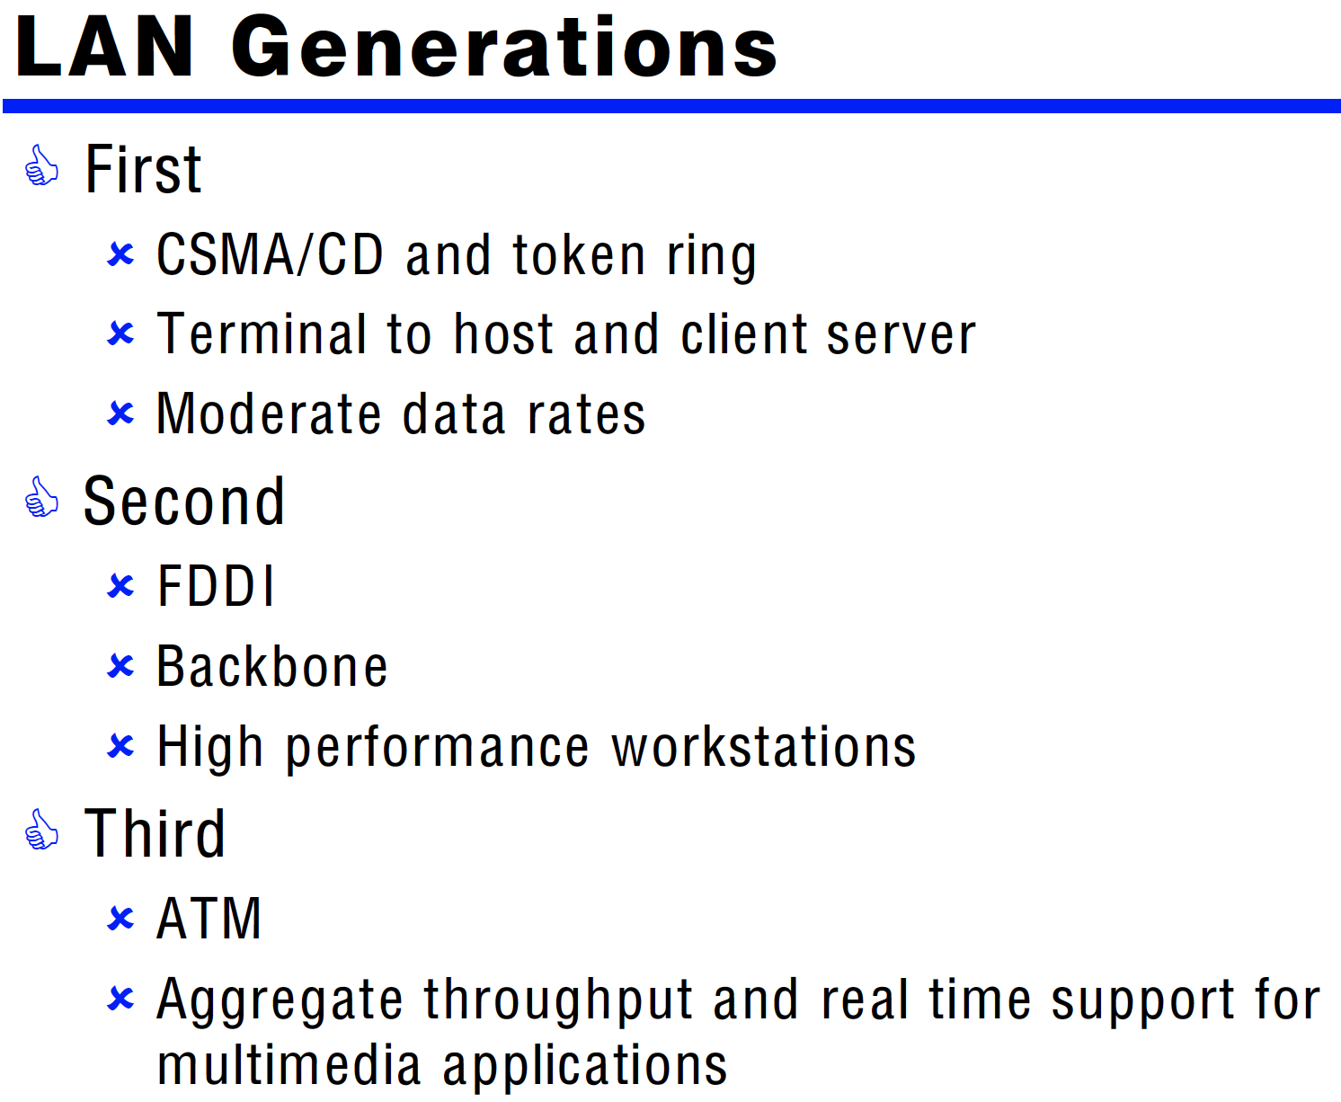

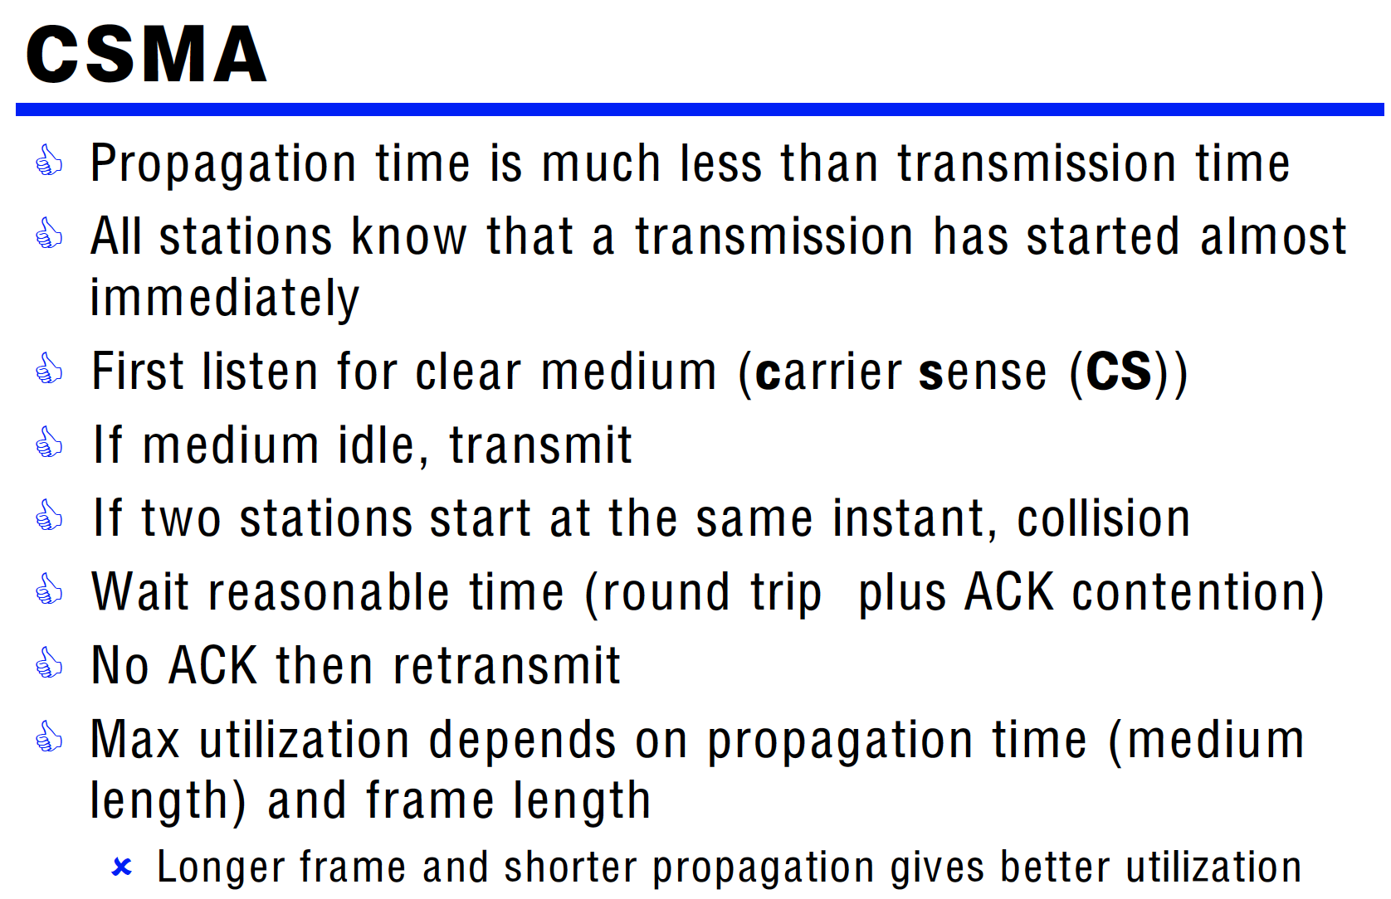

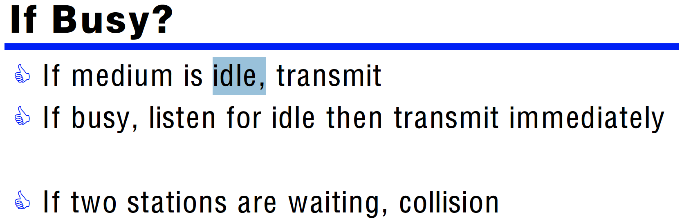

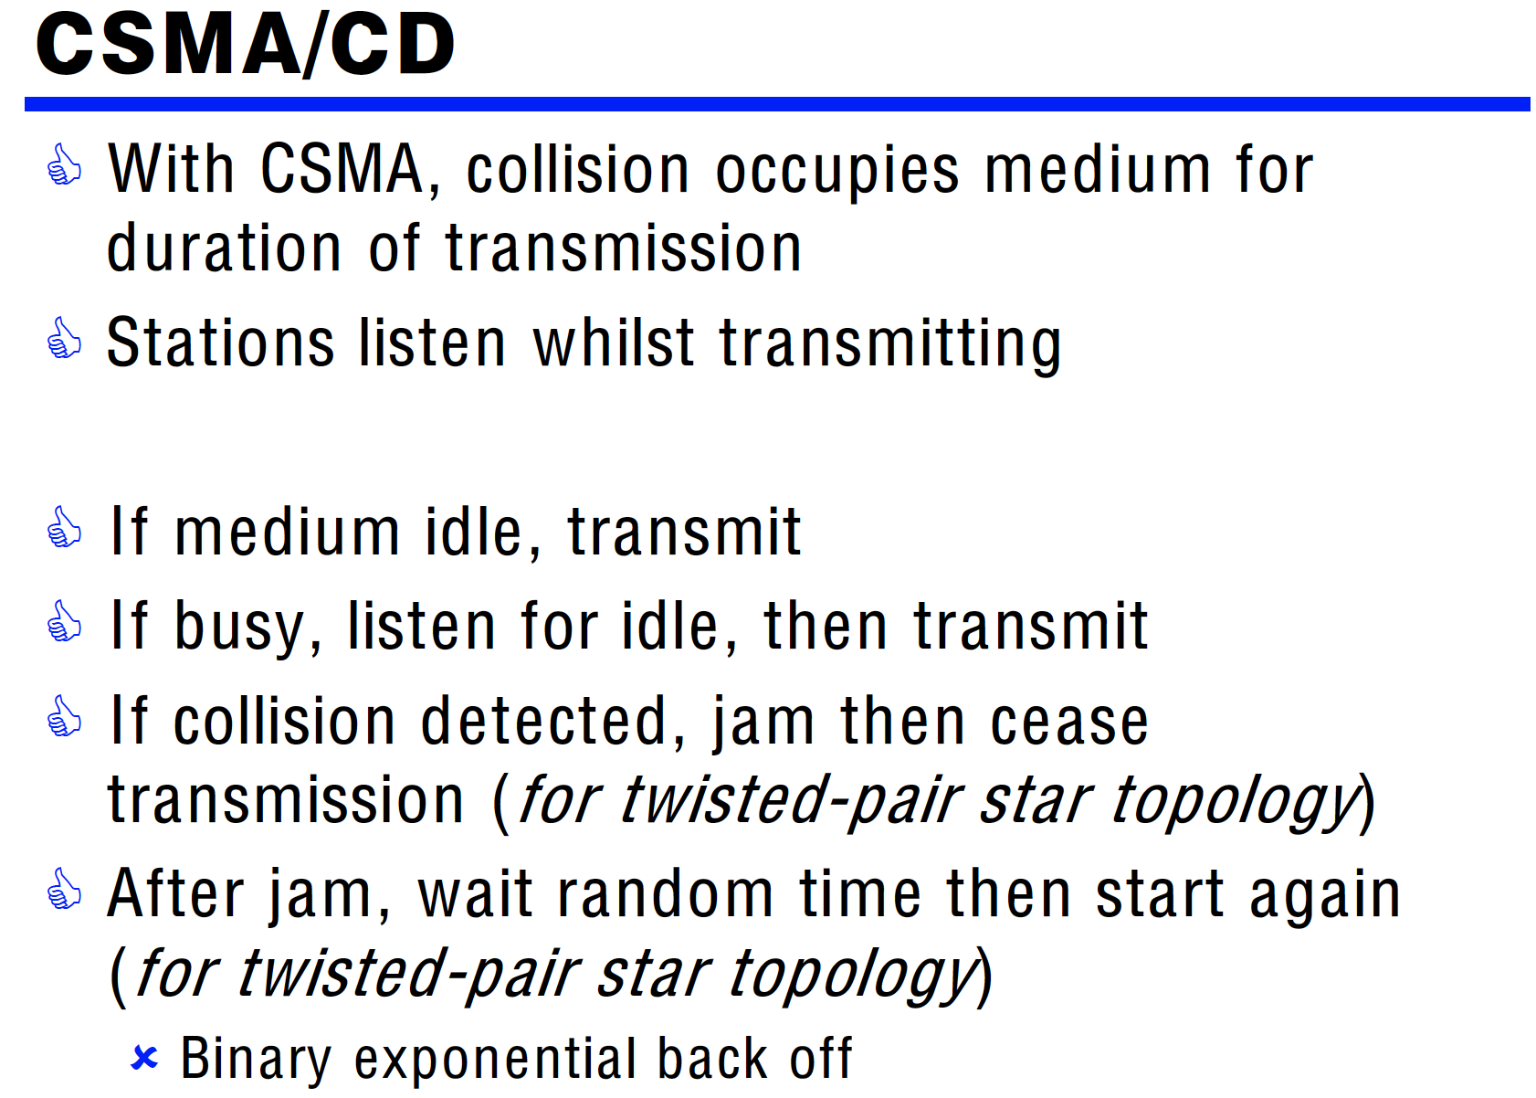

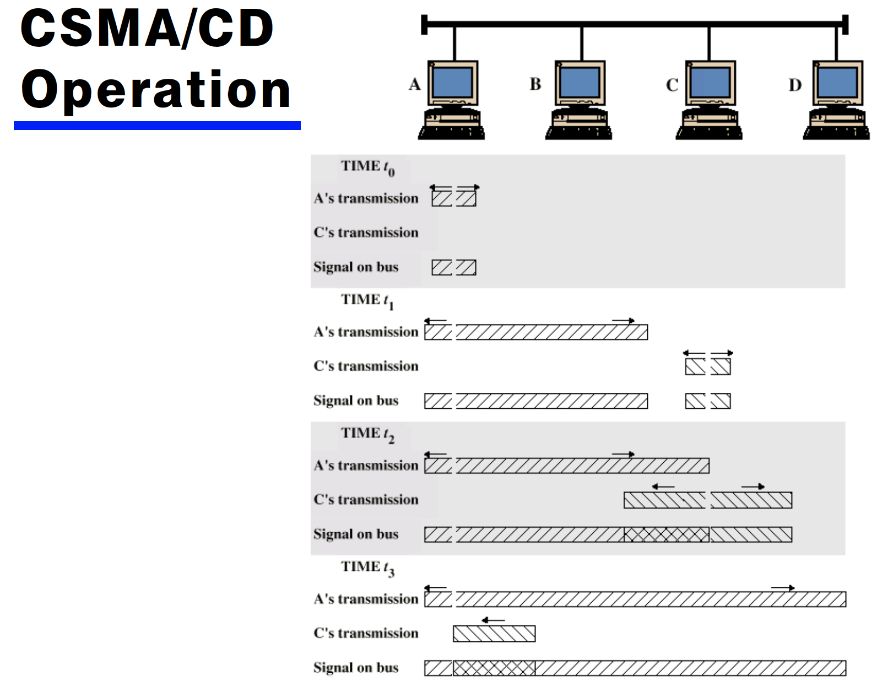

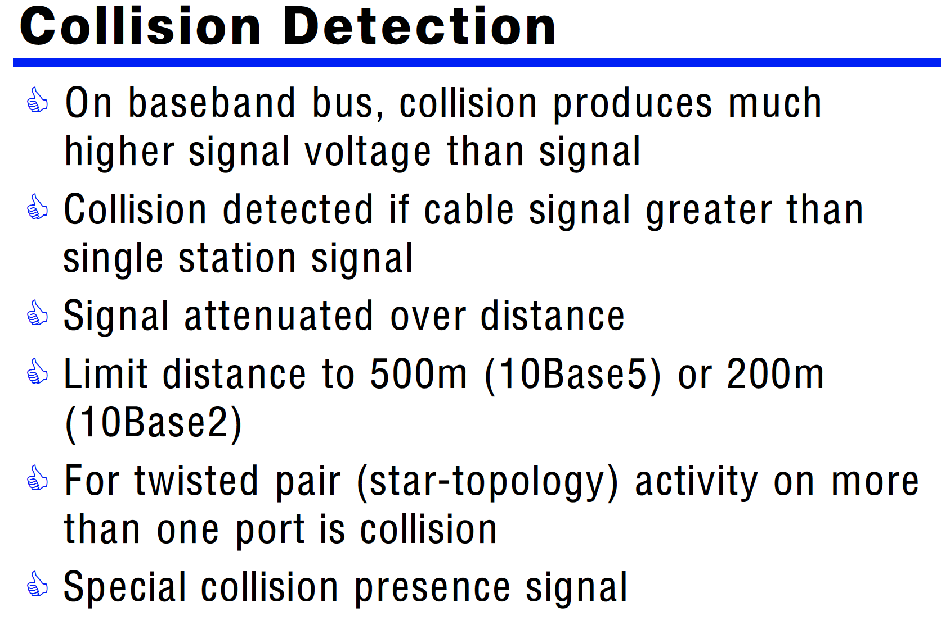

1. First Generation Lan: Token Ring

**令牌环**（权标环）（英语：Token-Ring）是定义在[IEEE 802.5](https://zh.wikipedia.org/wiki/IEEE_802.5" \o "IEEE 802.5)标准中的一种[局域网](https://zh.wikipedia.org/wiki/%E5%B1%80%E5%9F%9F%E7%BD%91" \o "局域网)接入方式。

令牌环网络的基本原理是利用令牌（代表发信号的许可）来避免网络中的冲突，它与使用冲突检测算法[CSMA/CD](https://zh.wikipedia.org/wiki/CSMA/CD" \o "CSMA/CD)的[以太网](https://zh.wikipedia.org/wiki/%E4%BB%A5%E5%A4%AA%E7%BD%91" \o "以太网)相比能提高网络的数据传送率。此外，它还可以设置发送的优先度。一个4M的令牌环网络和一个10M的[以太网](https://zh.wikipedia.org/wiki/%E4%BB%A5%E5%A4%AA%E7%BD%91" \o "以太网)数据传送率相当，一个16M的令牌环网络的数据传送率接近一个100M的以太网。但这种网络不可复用，导致网络利用率低下。当网络中一个结点拿到令牌而使用网络后，不管此结点使用多少带宽，其他结点都必须等待其使用完网络并放弃令牌后才有机会申请令牌并使用网络。此外，网络中还需专门结点维护令牌。

令牌环也暗示了除了使用令牌外，这还是一个环形[网络拓扑](https://zh.wikipedia.org/wiki/%E7%BD%91%E7%BB%9C%E6%8B%93%E6%89%91" \o "网络拓扑)。令牌环是一个[OSI 7层模型](https://zh.wikipedia.org/wiki/TCP/IP%E5%8F%82%E8%80%83%E6%A8%A1%E5%9E%8B" \o "TCP/IP参考模型)中的第二层（[数据链路层](https://zh.wikipedia.org/wiki/%E6%95%B0%E6%8D%AE%E9%93%BE%E8%B7%AF%E5%B1%82" \o "数据链路层)）协议。除了4Mbps、16Mbps外，IEEE 802.5还定义了100Mbps和1Gbps的数据传输率，不过后两者极少被用到。

令牌环网络是1980年代中期由[IBM](https://zh.wikipedia.org/wiki/IBM" \o "IBM)开发，很长一段时间是IBM的网络标准、被IBM生产所有的计算机支持。令牌环可以用[桥接器](https://zh.wikipedia.org/wiki/%E6%A9%8B%E6%8E%A5%E5%99%A8" \o "桥接器)或[路由器](https://zh.wikipedia.org/wiki/%E8%B7%AF%E7%94%B1%E5%99%A8" \o "路由器)连接其他网络。令牌环网络在实际应用中确实是“环”形网络，只不过由于使用所谓[多站接入单元](https://zh.wikipedia.org/wiki/%E5%A4%9A%E7%AB%99%E6%8E%A5%E5%85%A5%E5%8D%95%E5%85%83" \o "多站接入单元)设备而可以实现星形布线。这样的设备具有一定智能，会将不用的[端口](https://zh.wikipedia.org/wiki/%E7%AB%AF%E5%8F%A3" \o "端口)环接起来，使令牌畅通。IEEE 802.5标准主要基于IBM的令牌环网络，但也有一些细微差别。

## **传输方法**

发送数据时会由掌握令牌的计算机先发送数据。接收数据的计算机会检查帧表头，若是送给自己的则处理之。无论是否是送给自己的，都会再传下去，传一圈后检查数据是否相同以确定数据没有传输错误。待送完数据后可以依需要调整令牌的优先度（改得比自己的优先度低），再把令牌传递到下一台计算机。若接收到令牌但优先度较自己的高，则要把令牌传递到下一台计算机。

Dual ring improve reliability of a token ring network?

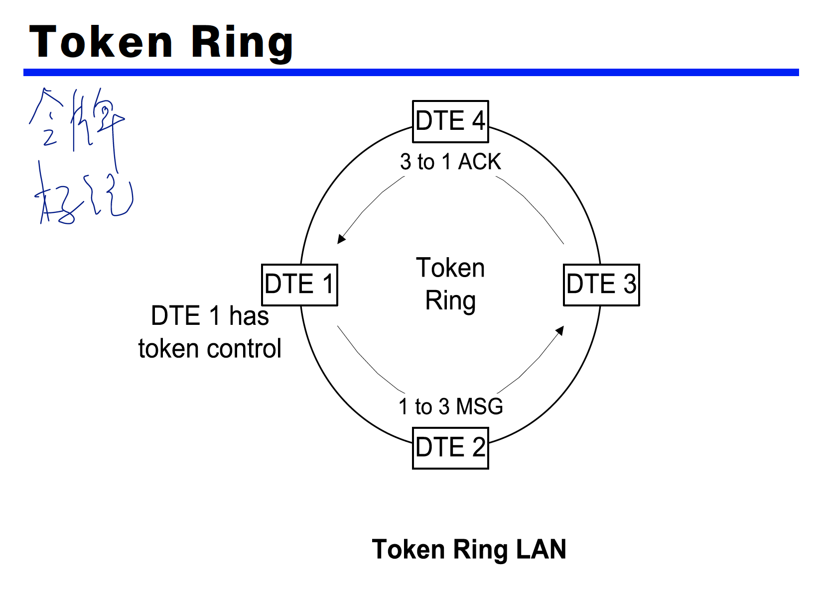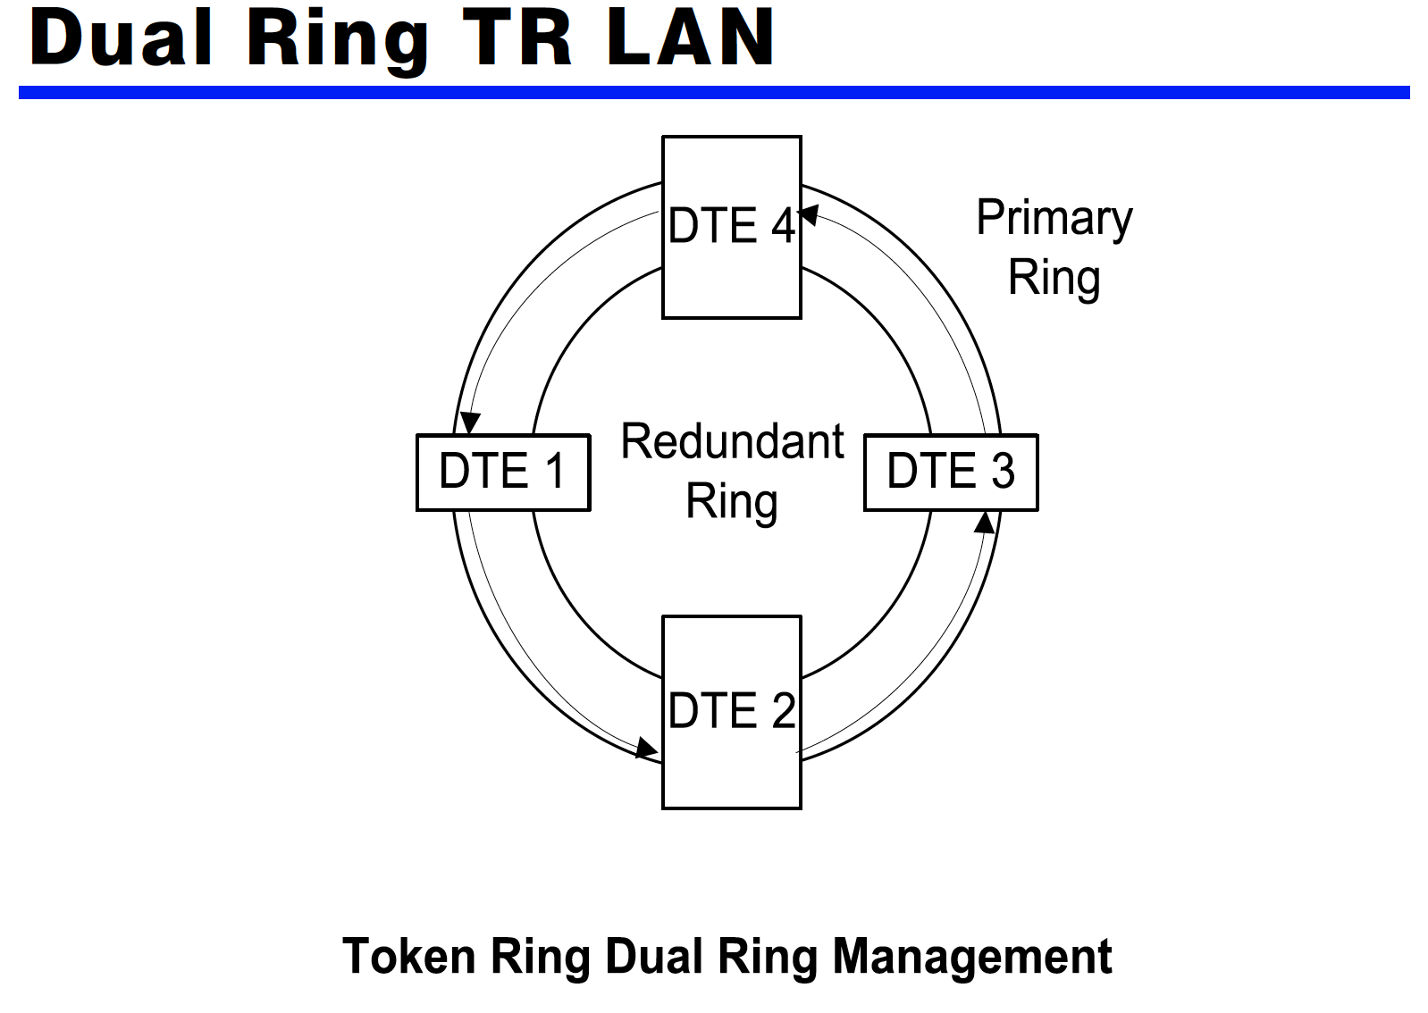

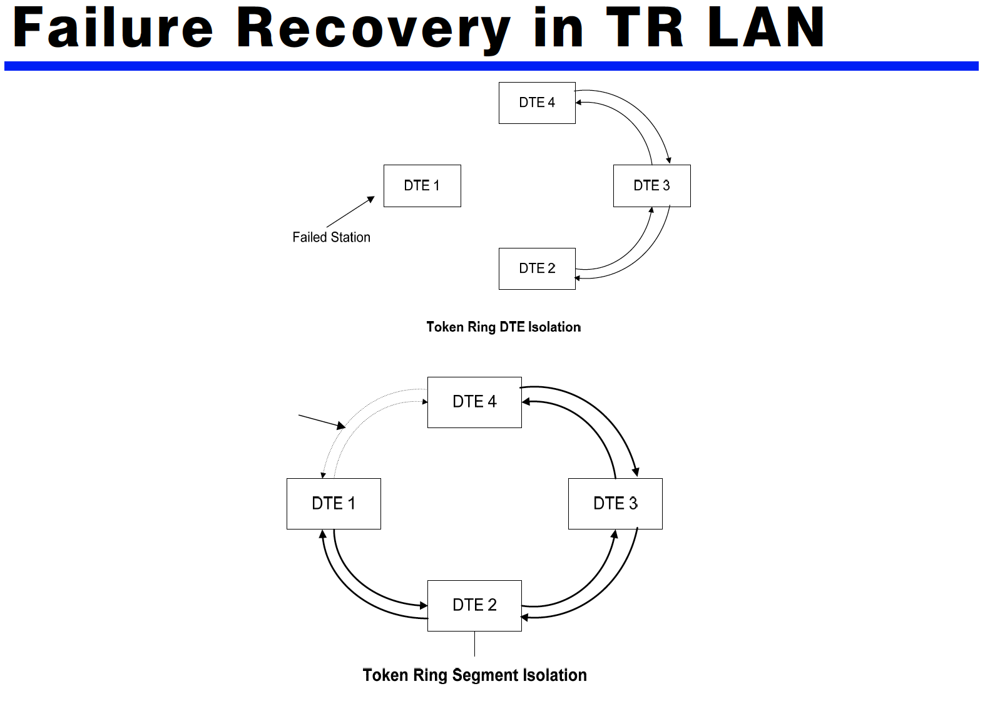

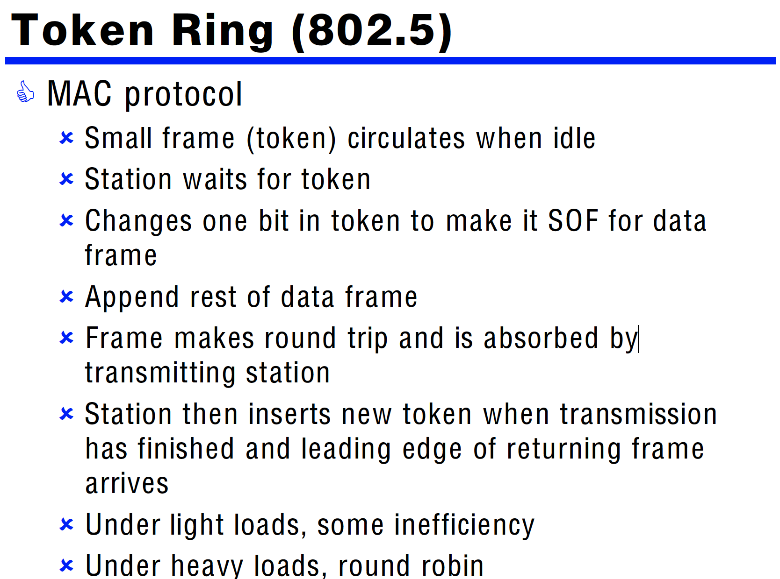

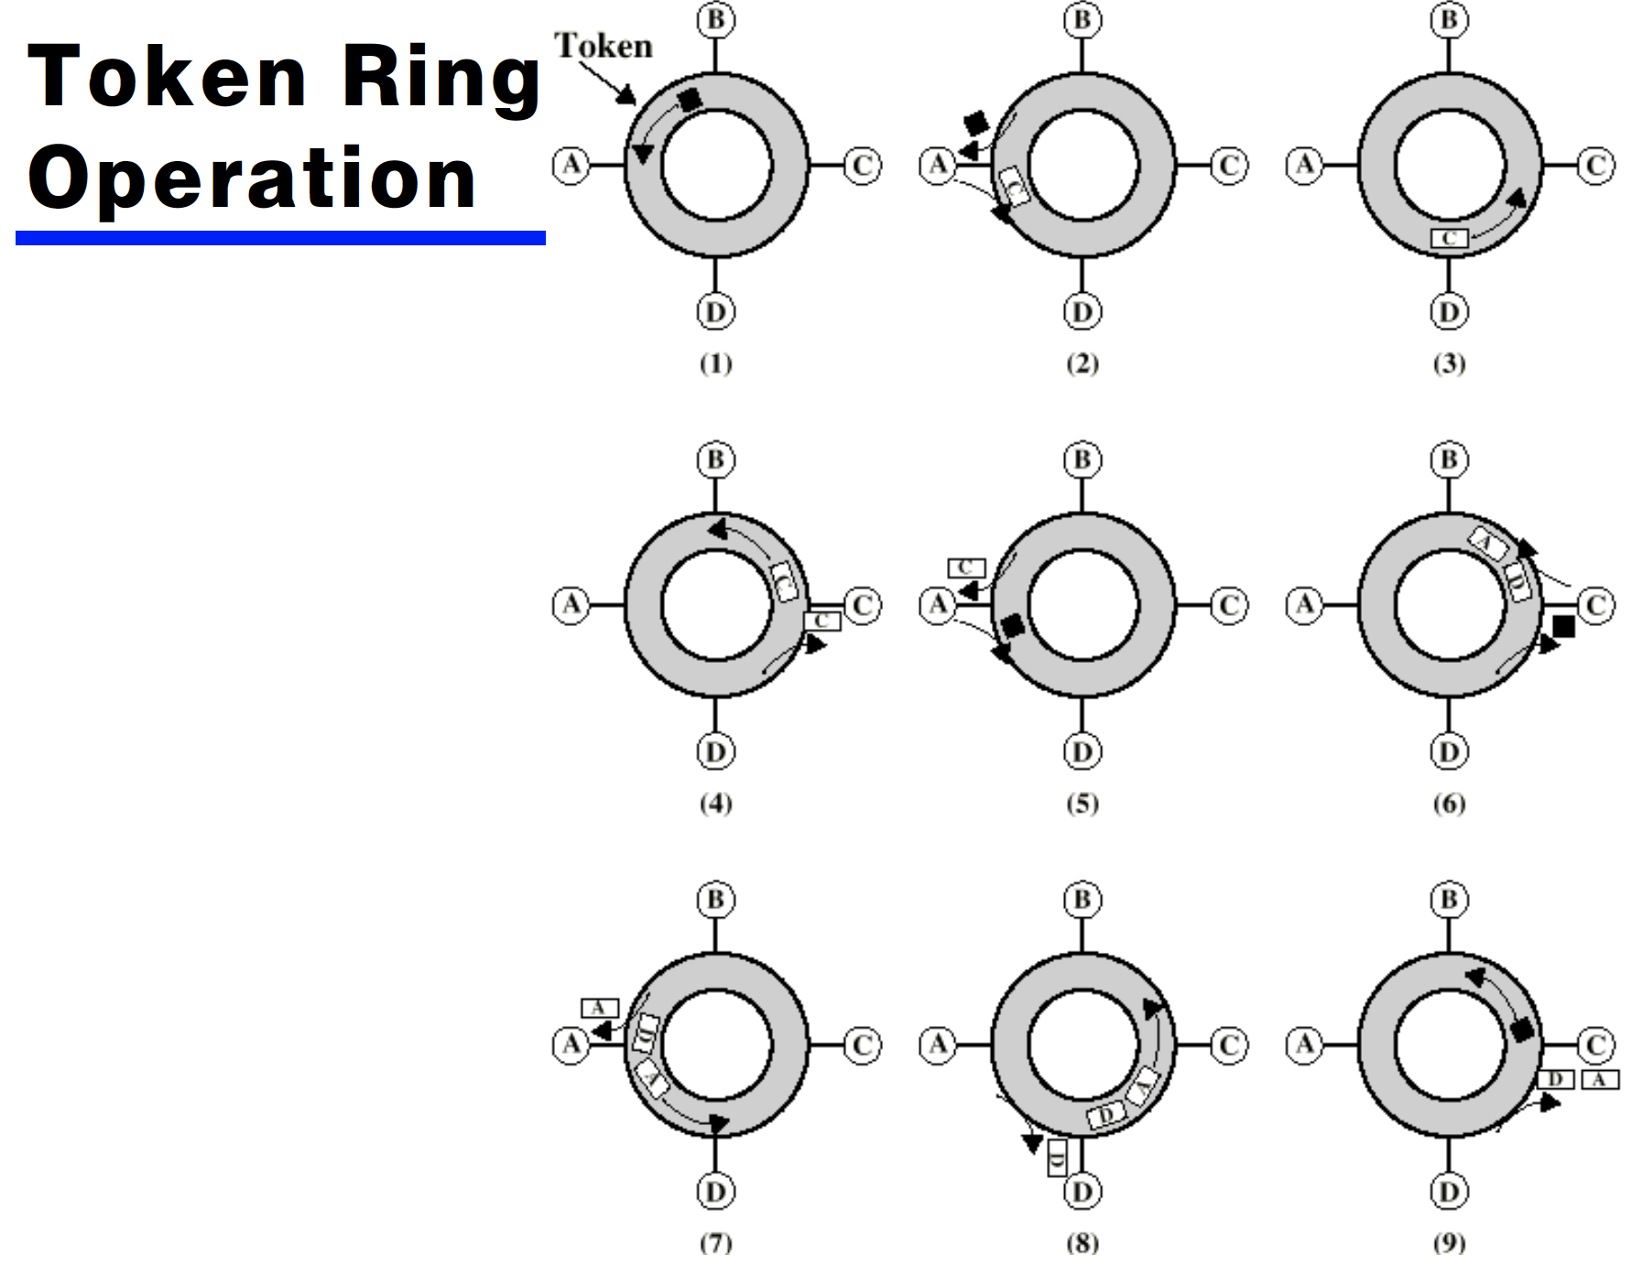

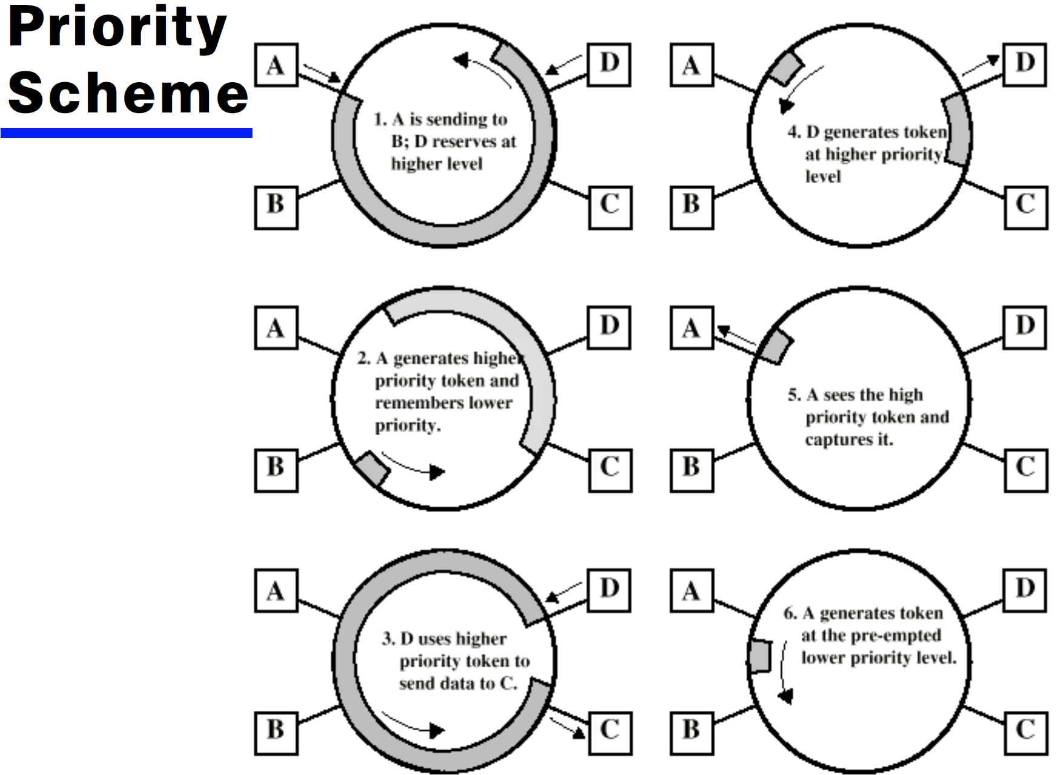

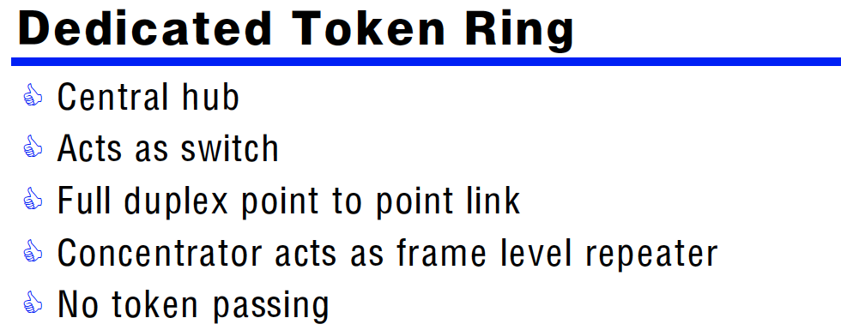

Second Generation Lan: FDDI

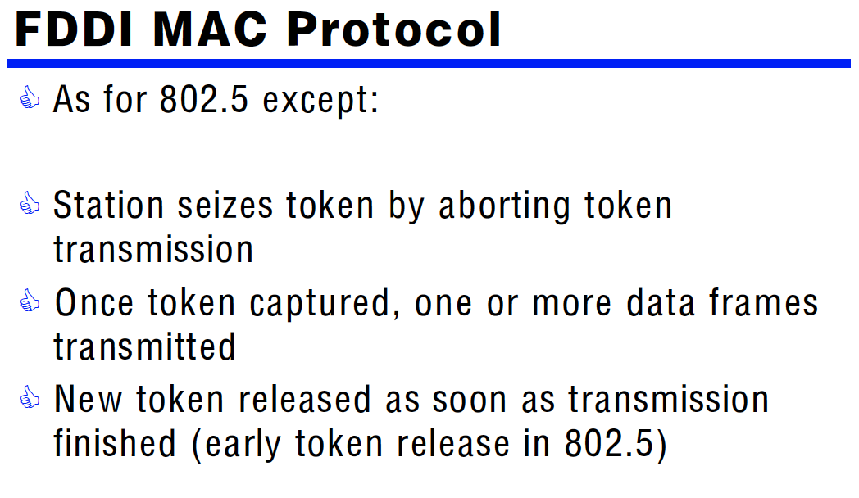



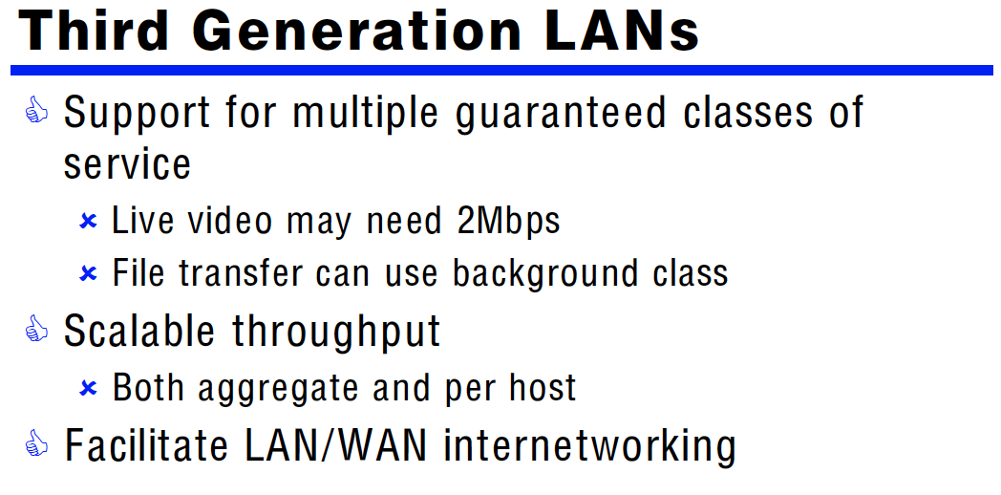

**异步传输模式**（英语：Asynchronous Transfer Mode，ATM），又叫[信元中继](https://zh.wikipedia.org/w/index.php?title=%E4%BF%A1%E5%85%83%E4%B8%AD%E7%BB%A7&action=edit&redlink=1" \o "信元中继（页面不存在）)。ATM采用[电路交换](https://zh.wikipedia.org/wiki/%E7%94%B5%E8%B7%AF%E4%BA%A4%E6%8D%A2" \o "电路交换)的方式，它以信元（cell）为单位。每个[信元](https://zh.wikipedia.org/w/index.php?title=%E4%BF%A1%E5%85%83&action=edit&redlink=1" \o "信元（页面不存在）)长53[字节](https://zh.wikipedia.org/wiki/%E5%AD%97%E8%8A%82)。其中报头占了5字节。

ATM能够比较理想地实现各种[QoS](https://zh.wikipedia.org/wiki/QoS" \o "QoS)，既能够支持有连接的业务，又能支持无连接的业务。是[宽带ISDN](https://zh.wikipedia.org/w/index.php?title=%E5%AE%BD%E5%B8%A6ISDN&action=edit&redlink=1" \o "宽带ISDN（页面不存在）)（[B-ISDN](https://zh.wikipedia.org/w/index.php?title=B-ISDN&action=edit&redlink=1)）技术的典范。ATM为一种交换技术，在发送数据时，先将数字数据切割成多个固定长度的数据包，之后利用光纤或DS1/ DS3发送。到达目的地后，再重新组合。ATM网络可同时将声音、影像及数据集成在一起。针对各种信息类型，提供最佳的传输环境。

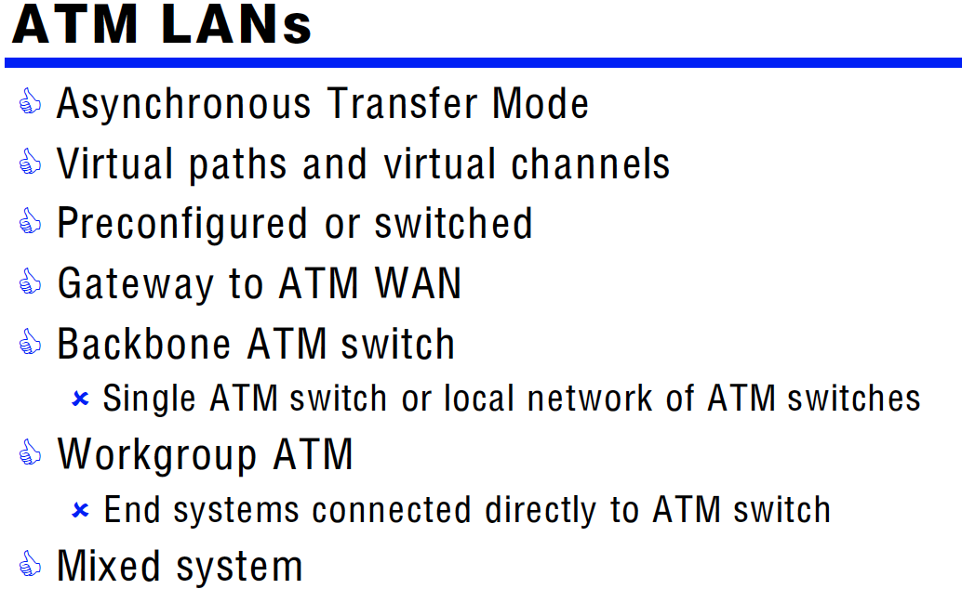

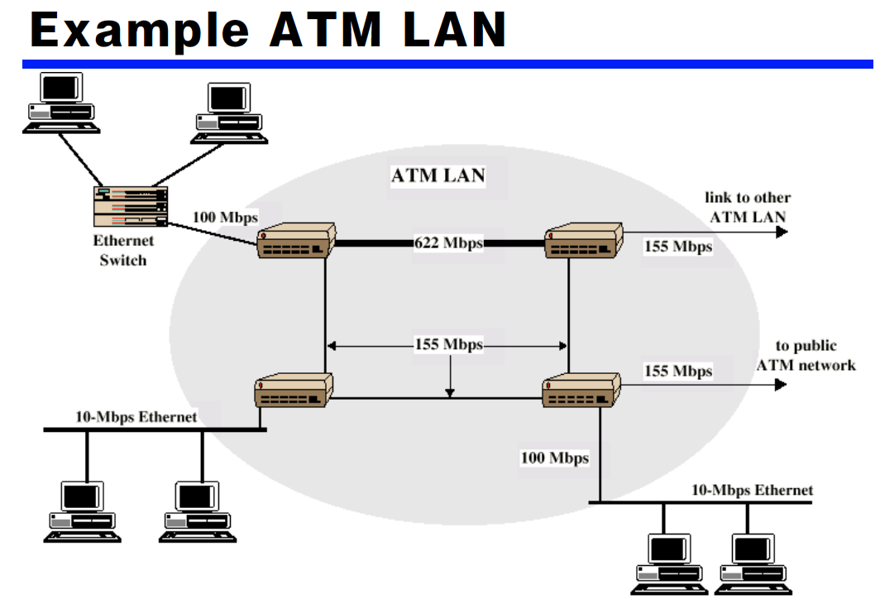

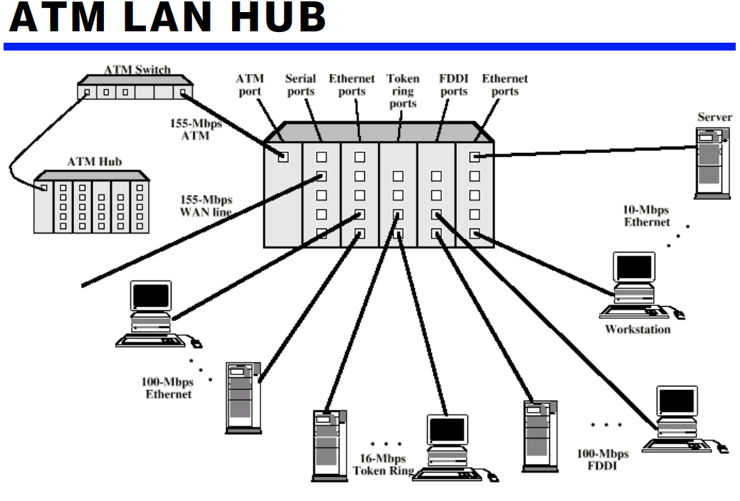

1. Basic Network Nodes
2. **Repeater**

A repeater operates at the **physical layer**. Its job is to **regenerate the signal over the same network before the signal becomes too weak** or corrupted so as to extend the length to which the signal can be transmitted over the same network. An important point to be noted about repeaters is that they do not amplify the signal. When the signal becomes weak, they **copy the signal bit by bit and regenerate it at the original strength. It is a 2 port device.**

1. **Hubs**

A hub is basically a **multiport repeater**. A hub connects multiple wires coming from different branches, for example, the connector in star topology which connects different stations. Hubs **cannot filter data**, so data packets are sent to all connected devices.  In other words, [collision domain](https://en.wikipedia.org/wiki/Collision_domain) of all hosts connected through Hub remains one.  Also, they do not have intelligence to find out best path for data packets which leads to inefficiencies and wastage.

1. **Bridges**

A bridge operates at **data link layer**. A bridge is a **repeater**, with add on functionality of **filtering** content by **reading the MAC addresses of source and destination**. It is also used for interconnecting two LANs working on the same protocol. It has a single input and single output port, thus making it a 2 port device.

1. **Remote bridges**
2. **Switches**

A switch is a multi-port bridge with a buffer and a design that can boost its efficiency(large number of  ports imply less traffic) and performance. Switch is **data link layer** device. Switch can perform **error checking** before forwarding data, that makes it very efficient as it does not forward packets that have errors and  **forward good packets selectively to correct port only**.  In other words, switch divides collision domain of hosts, but [broadcast domain](https://en.wikipedia.org/wiki/Broadcast_domain) remains same.

1. **Routers**

A router is a device like a switch that **routes data packets based on their IP addresses**. Router is mainly a Network Layer device. Routers normally **connect LANs and WANs** together and have a dynamically updating routing table based on which they make decisions on routing the data packets. Router divide broadcast domains of hosts connected through it.

1. **Gateways**

A gateway, as the name suggests, is a passage to connect two networks together that may work upon different networking models. They basically works as the messenger agents that take data from one system, interpret it, and transfer it to another system. Gateways are also called **protocol converters** and can operate at any network layer. Gateways are generally more complex than switch or router.

1. **Half bridge / half router**

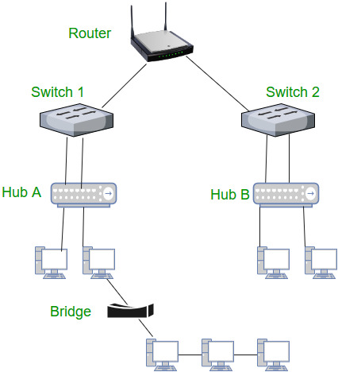

<https://www.geeksforgeeks.org/network-devices-hub-repeater-bridge-switch-router-gateways/>

1. Basic LAN Topologies
2. Bus Topology

## 

1. Ring Topology

* Repeaters joined by point to point links in closed loop
* Receive data on one link and retransmit on another
* Links unidirectional
* Stations attach to repeaters
* Data in frames
* Circulate past all stations
* Destination recognizes address and copies frame
* Frame circulates back to source where it is removed
* Media access control determines when station can insert frame

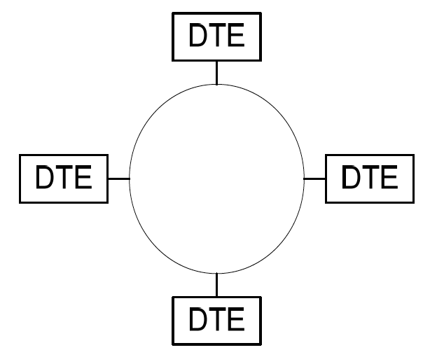 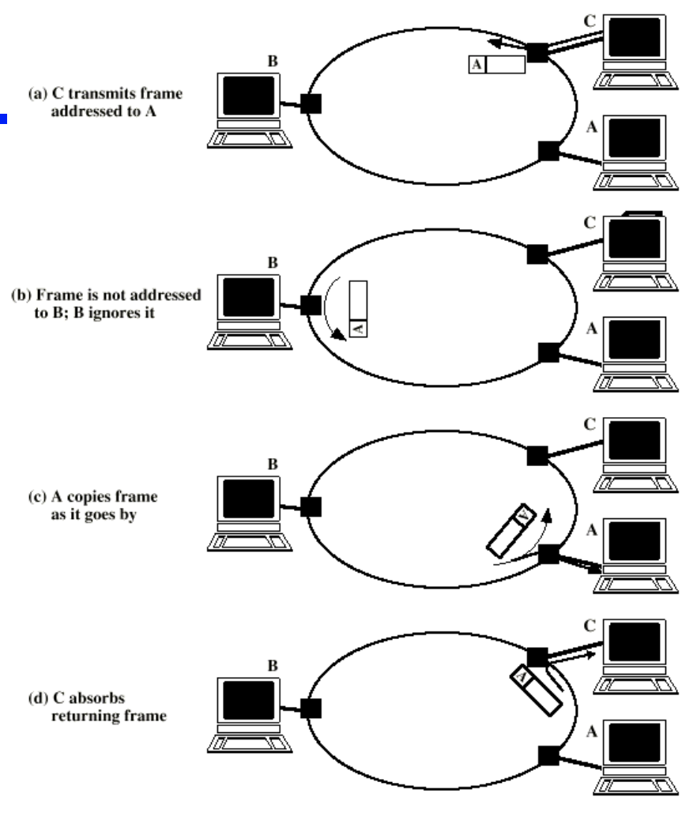

1. Star Topology

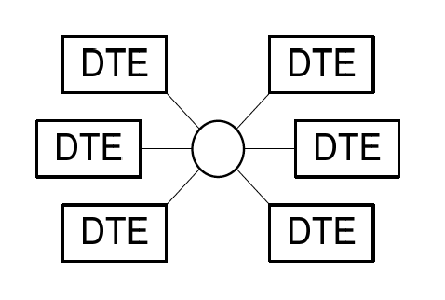

* Each station connected directly to central node
* Usually via two point to point links
* Central node can broadcast
* Physical star, logical bus
* Only one station can transmit at a time
* Central node can act as frame switch

1. Hub Configurations

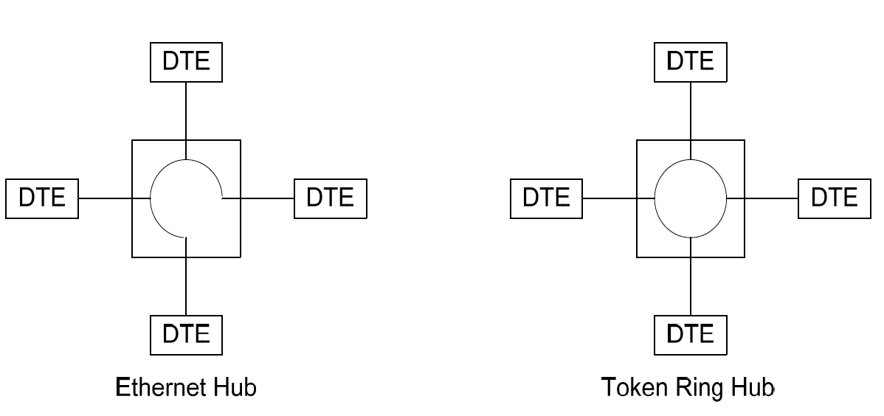

1. Virtual Local Area Network (VLAN)

Frequent travellers, Company exchange data, improve security

Serial ports locally -> Internet by users outside， VPN

VPN: a computer network that uses a public telecommunication infrastructure such as the Internet to provide remote offices or individual users with secure access to their organization's network

VLAN: can be viewed as a group of devices on different physical LAN segments which can communicate with each other as if they were all on the same physical LAN. segment.

VLAN benefits:

1. Increased performance
2. Improved manageability
3. Network tuning and simplification of software configurations
4. Physical topology independence
5. Increased security options

* Secure VPNs use cryptographic tunnelling protocols to provide confidentiality by blocking intercepts and packet sniffing, allowing sender authentication to block identity spoofing, and provide message integrity by preventing message alteration.

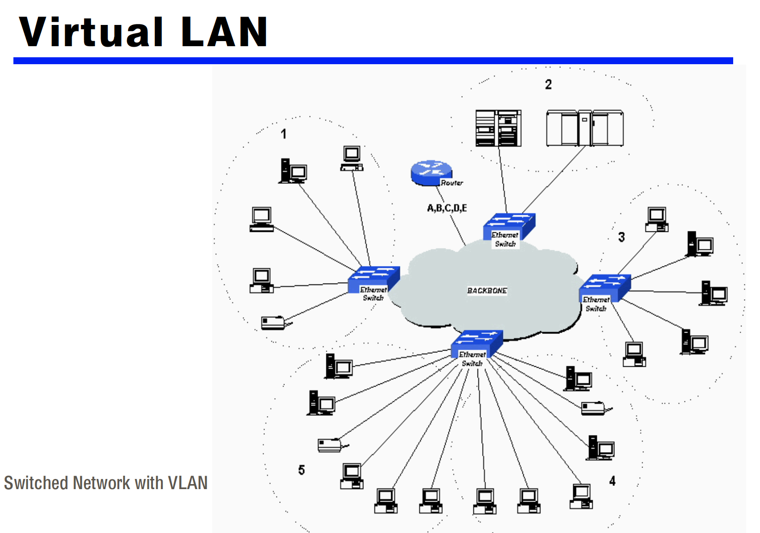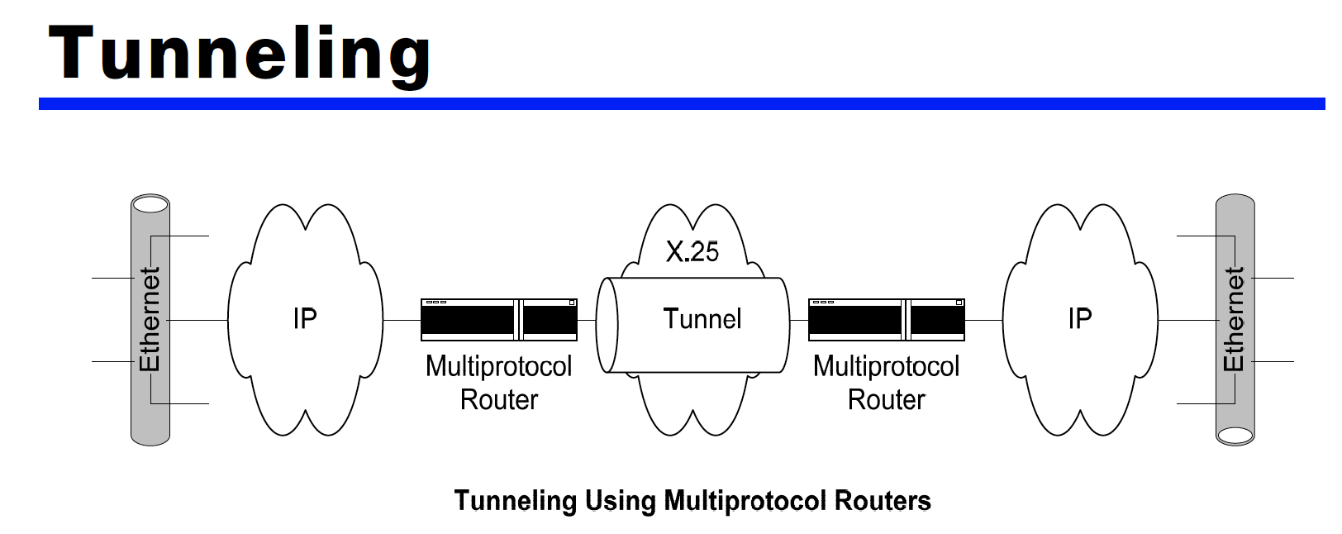

1. Sockets used to provide multiple services concurrently
2. TCP or UDP, video Conferencing system.

**网络套接字**（英语：Network socket），又译**网络套接字**、**网络接口**、**网络插槽**，是计算机网络中[行程间](https://zh.wikipedia.org/wiki/%E8%A1%8C%E7%A8%8B%E9%96%93%E9%80%9A%E8%A8%8A" \o "行程间通信)数据流的端点。

在[操作系统](https://zh.wikipedia.org/wiki/%E4%BD%9C%E6%A5%AD%E7%B3%BB%E7%B5%B1" \o "操作系统)中，通常会为应用程序提供一组[应用程序接口](https://zh.wikipedia.org/wiki/%E6%87%89%E7%94%A8%E7%A8%8B%E5%BC%8F%E4%BB%8B%E9%9D%A2" \o "应用程序接口)（API），称为**套接字接口**（英语：socket API）。应用程序可以通过套接字接口，来使用网络套接字，以进行数据交换。在套接字接口中，以[IP地址](https://zh.wikipedia.org/wiki/IP%E5%9C%B0%E5%9D%80" \o "IP地址)及[通信端口](https://zh.wikipedia.org/wiki/%E9%80%9A%E8%A8%8A%E5%9F%A0" \o "通信端口)组成**套接字地址**（socket address）。远程的套接字地址，以及本地的套接字地址完成连线后，再加上使用的协议（protocol），这个五元组（five-element tuple），作为**套接字对**（socket pairs），之后就可以彼此交换数据。例如，在同一台计算机上，TCP协议与UDP协议可以同时使用相同的port而互不干扰。 操作系统根据套接字地址，可以决定应该将数据送达特定的[行程](https://zh.wikipedia.org/wiki/%E8%A1%8C%E7%A8%8B" \o "行程)或[线程](https://zh.wikipedia.org/wiki/%E5%9F%B7%E8%A1%8C%E7%B7%92" \o "线程)。这就像是[电话](https://zh.wikipedia.org/wiki/%E9%9B%BB%E8%A9%B1" \o "电话)系统中，以[电话号码](https://zh.wikipedia.org/wiki/%E9%9B%BB%E8%A9%B1%E8%99%9F%E7%A2%BC" \o "电话号码)加上分机号码，来决定通话对象一般。

Socket is an abstraction for an end point of communication that can be manipulated with a file descriptor.

It is an abstract object from which messages are sent and received.

Sockets are created within a communication domain just as files are created within a file system.

* 1. Server handling multiple clients at the same time
  2. Client and server on the same Ethernet communicating with TCP



* 1. Client and server on different LANs connected through a WAN

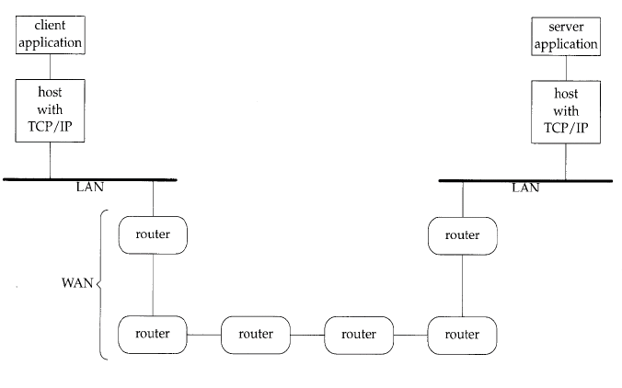

Inter-process communication via sockets is based on client-server model:

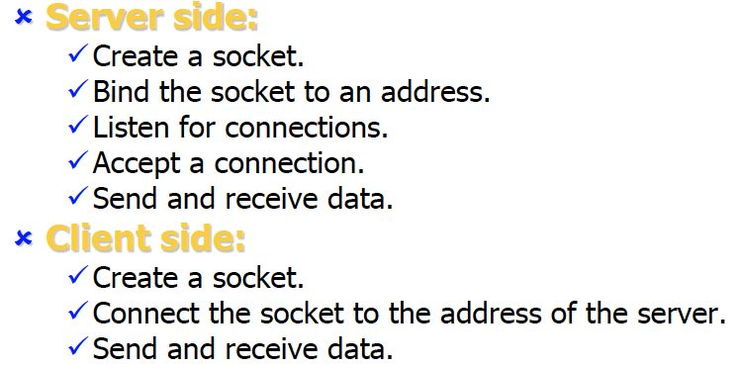

Two processes can communicate with each other only if their sockets are of the same type and in the same domain.

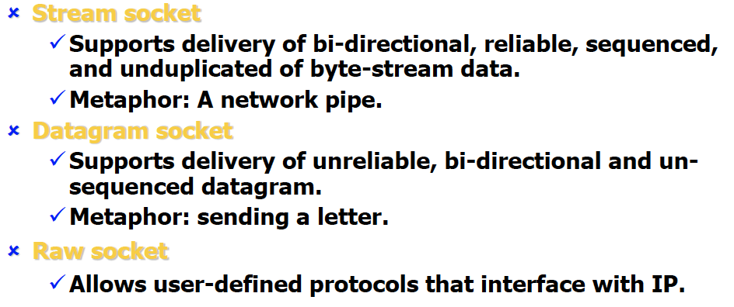

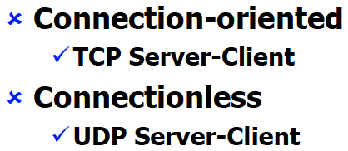

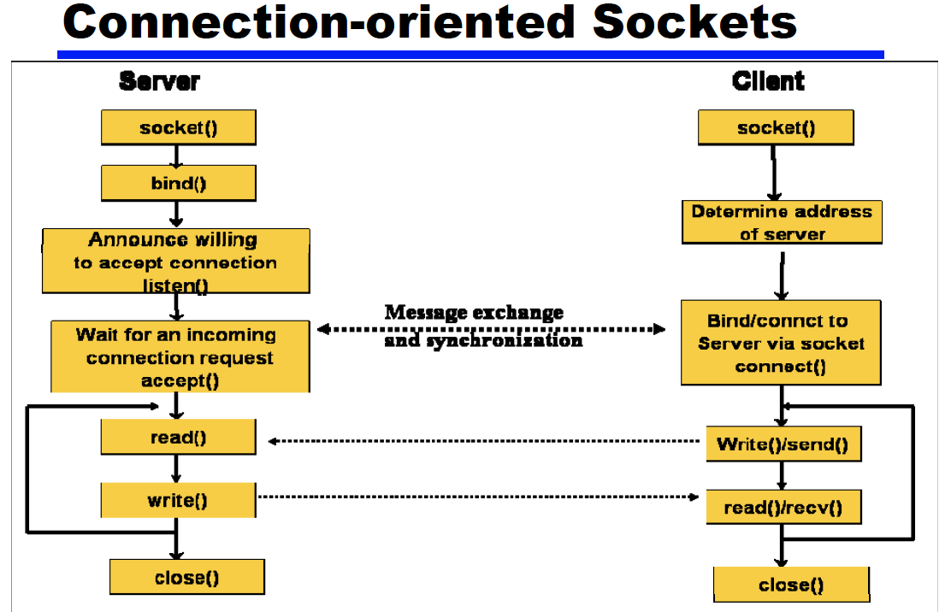

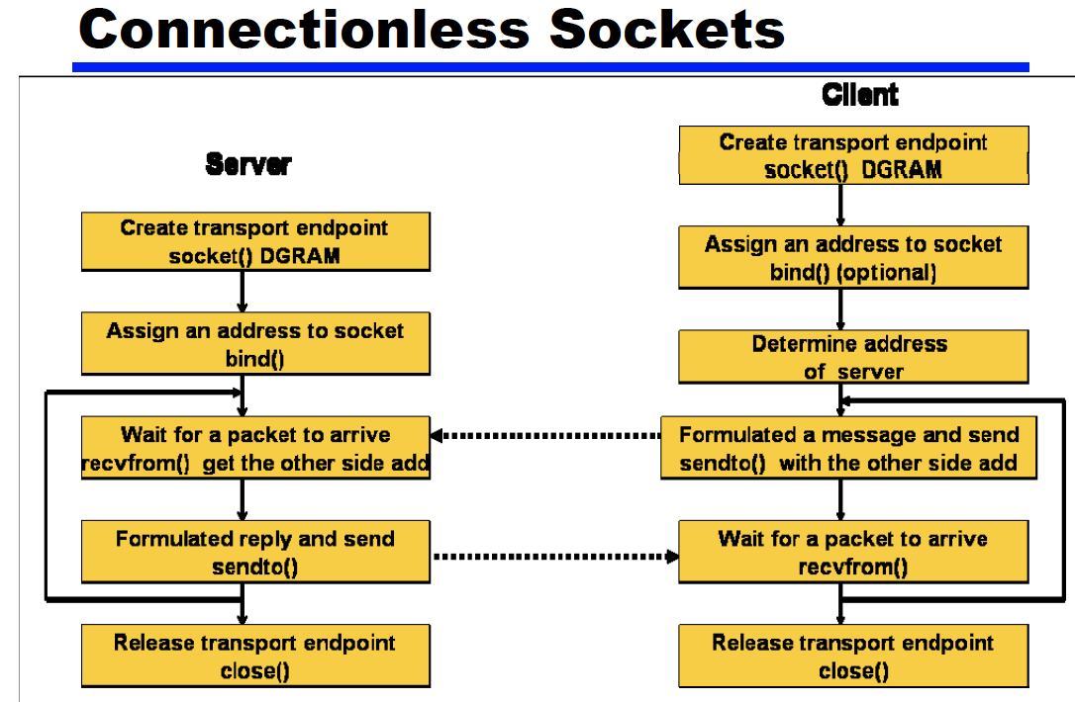

1. Can Multiprocesses and multithreads concurrent be used in one server?

Multi-threads be synchronized

Multi-processes or multi-threads in big data?

A program is a sequence of instructions.

A process is a dynamic invocation of a program along with the resources required to run.

A Unix process is an instance of an executing program: it has a separate existence from all the other processes on the system.

Threads (lightweight process)

Share same global memory within the process



1. Field Bus <-> Internet

Fieldbus is the name of a family of industrial computer network protocols used for real-time distributed control, now standardized as IEC 61158.

Fieldbuses are communication technologies and products used in vehicular, automation and process control industries.

Field buses are special LANs that are dedicated to data acquisition and the control of sensors and actuators.

They typically run over low-cost twisted pair cable.

They differ from many traditional LANs (such as Ethernet) in that they are **optimized for the exchange of short point-to-point status and command messages.**

Two basic categories: device and process.

Device-type buses are intended to handle the transmission of short messages a few bytes in length.

Device buses can be broken into two categories: bit-wide and byte-wide buses.

Process Buses

􀀸 Capable of communicating several hundred bytes of data per transmission.

􀀸 Are slower because of their large data packet size.

􀀸 Most analog control devices do not require fast response times.

􀀸 Process controllers typically are smart devices.

􀀹 They are typically controlling analog types of variables like flow, concentration, temperature, etc.

􀀹 Most devices in a process bus network are analog.

􀀹 These processes are typically slow to respond.

􀀸 Process buses are used to transmit process parameters to process controllers.

1. Control Area Networks (CAN) and Internet (major differences)

Controller Area Network (CAN) is a fast serial bus that is designed to provide an efficient, reliable and very economical link between sensors and actuators.

CAN fieldbuses are now used in machine and factoryautomation products as well.

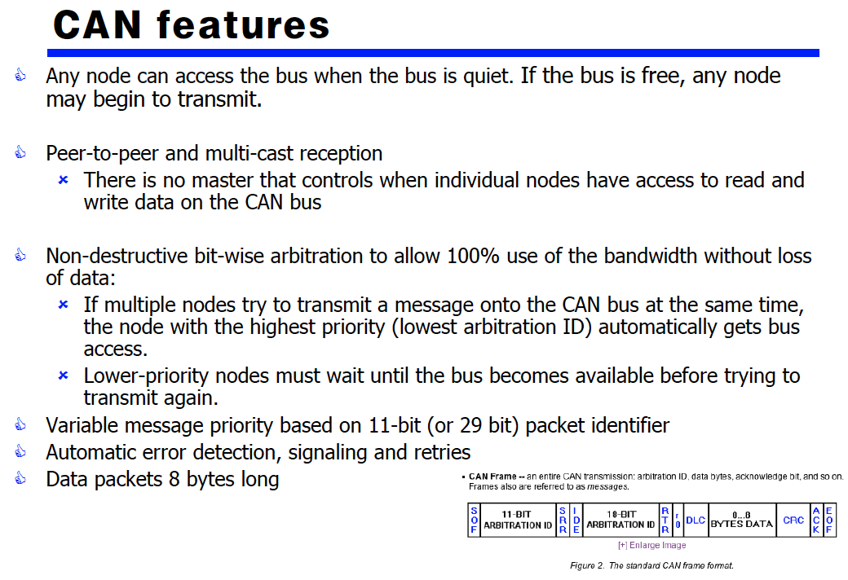

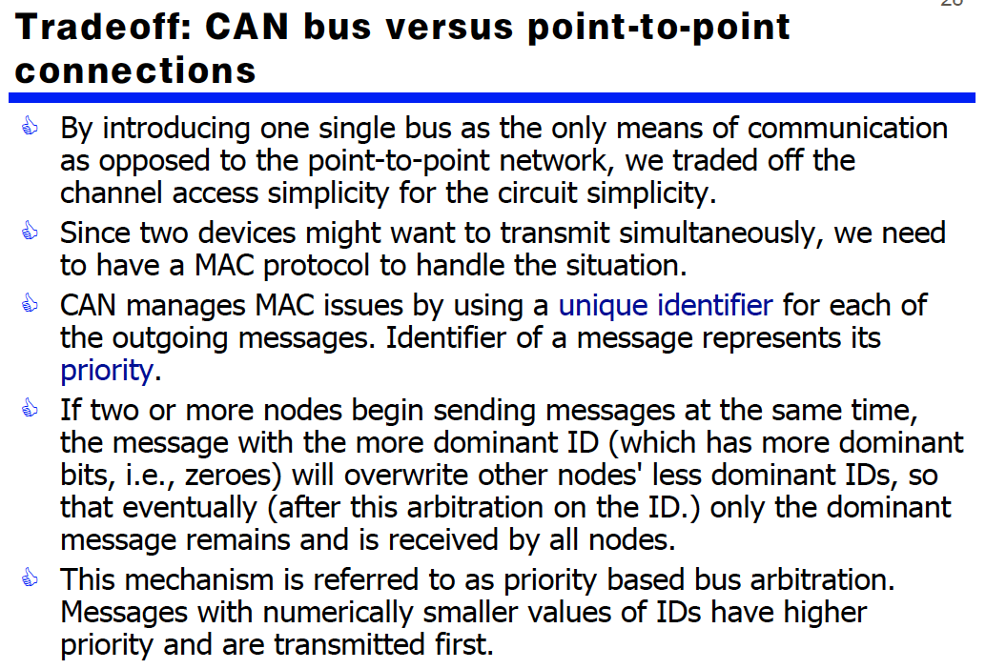

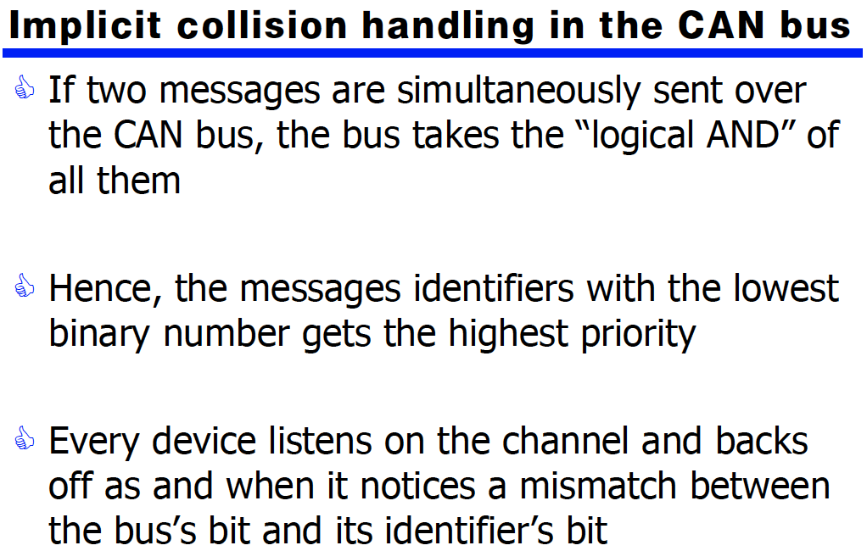

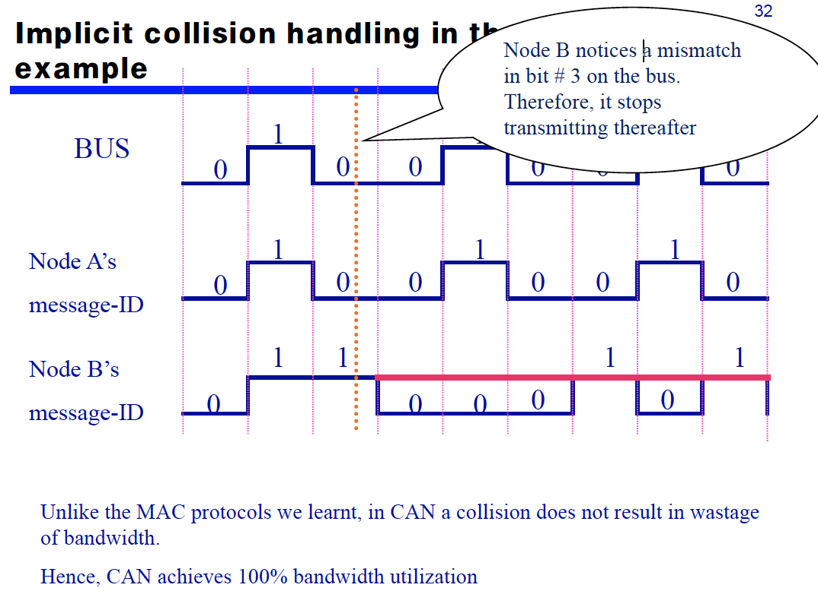

1. PROFIBUS (Process Field Bus)

An industrial control network used for factory automation, process control, motion control and safety networks.

The topology used is the serial bus, terminated at both ends.

Profibus is based on the token passing and master-slave system.

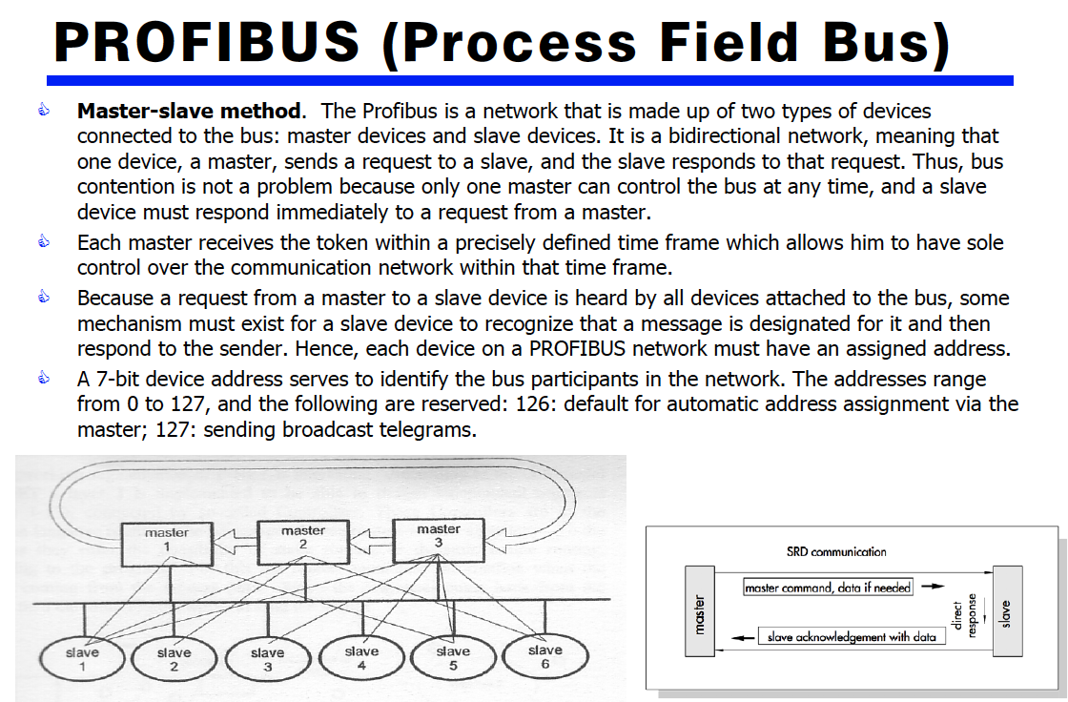

1. Leased network
2. IP address, routing strategy (why the web server with the changed IP address can be accessible remotely)
3. PSTN (Public Switch Telephone network), VoIP (Voice over IP)
4. 瞎掰题
5. AI
6. IoT

**物联网**（英语：Internet of Things[[2]](https://www.researchgate.net/profile/Morteza_Mohammadi_Zanjireh/publication/274638337_A_Survey_on_Centralised_and_Distributed_Clustering_Routing_Algorithms_for_WSNs/links/552444b80cf2b123c5173968/A-Survey-on-Centralised-and-Distributed-Clustering-Routing-Algorithms-for-WSNs.pdf)，缩写物联网）是[互联网](https://zh.wikipedia.org/wiki/%E4%BA%92%E8%81%94%E7%BD%91" \o "互联网)、传统电信网等信息承载体，让所有能行使独立功能的普通物体实现互联互通的网络[[1]](https://zh.wikipedia.org/wiki/%E7%89%A9%E8%81%94%E7%BD%91" \l "cite_note-intro-1)。物联网一般为[无线](https://zh.wikipedia.org/wiki/%E6%97%A0%E7%BA%BF" \o "无线)网，而由于每个人周围的[设备](https://zh.wikipedia.org/wiki/%E8%AE%BE%E5%A4%87" \o "设备)可以达到一千至五千个，所以物联网可能要包含500兆至一千兆个物体。在物联网上，每个人都可以应用[电子标签](https://zh.wikipedia.org/wiki/%E5%B0%84%E9%A2%91%E8%AF%86%E5%88%AB" \o "射频识别)将真实的物体上网联结，在物联网上都可以查出它们的具体位置。通过物联网可以用中心[计算机](https://zh.wikipedia.org/wiki/%E8%AE%A1%E7%AE%97%E6%9C%BA" \o "计算机)对[机器](https://zh.wikipedia.org/wiki/%E6%9C%BA%E5%99%A8" \o "机器)、[设备](https://zh.wikipedia.org/wiki/%E8%AE%BE%E5%A4%87" \o "设备)、[人员](https://zh.wikipedia.org/w/index.php?title=%E4%BA%BA%E5%91%98&action=edit&redlink=1" \o "人员（页面不存在）)进行集中[管理](https://zh.wikipedia.org/wiki/%E7%AE%A1%E7%90%86" \o "管理)、[控制](https://zh.wikipedia.org/wiki/%E6%8E%A7%E5%88%B6" \o "控制)，也可以对家庭设备、[汽车](https://zh.wikipedia.org/wiki/%E6%B1%BD%E8%BD%A6" \o "汽车)进行[遥控](https://zh.wikipedia.org/wiki/%E9%81%99%E6%8E%A7" \o "遥控)，以及搜索位置、防止物品被盗等，类似自动化操控系统，同时透过收集这些小事的数据，最后可以聚集成[大数据](https://zh.wikipedia.org/wiki/%E5%A4%A7%E6%95%B8%E6%93%9A" \o "大数据)，包含重新设计道路以减少车祸、都市更新、灾害预测与犯罪防治、流行病控制等等社会的重大改变，实现物和物相联。

物联网将现实世界[数字化](https://zh.wikipedia.org/wiki/%E6%95%B8%E5%AD%97%E5%8C%96%E9%9D%A9%E5%91%BD" \o "数字化革命)，应用范围十分广泛。物联网拉近分散的信息，统整物与物的数字信息，物联网的应用领域主要包括以下方面：运输和物流领域、工业制造[[2]](https://zh.wikipedia.org/wiki/%E7%89%A9%E8%81%94%E7%BD%91" \l "cite_note-IoT_in_Manuf-Survey-2)、健康医疗领域范围、智能环境（家庭、办公、工厂）领域、个人和社会领域等[[3]](https://zh.wikipedia.org/wiki/%E7%89%A9%E8%81%94%E7%BD%91" \l "cite_note-The_Internet_of_Things:_A_survey-3)，具有十分广阔的市场和应用前景。

1. 自动驾驶
2. 5G替代wifi
3. Cloud computing